**1: Write a program to create student class with data members rollno, marks1, mark2, mark3.**

**Accept data (acceptInfo()) and display using display member function.**

**Also display total,percentage and grade.**

Program :

Code:

**package** com.code;

**public** **class** StdMark {

**private** **int** mark1;

**private** **int** mark2;

**private** **int** mark3;

**private** **int** total;

**public** **void** acceptinfo(**int** mark1, **int** mark2, **int** mark3) {

**this**.mark1=mark1;

**this**.mark2=mark2;

**this**.mark3=mark3;

}

**public** **int** TotalMark() {

**this**.total=**this**.mark1+**this**.mark2+**this**.mark3;

**return** **this**.total;

}

}

Tester :

**package** TesterStd;

**import** java.util.Scanner;

**import** com.code.StdMark;

**public** **class** TesterStd {

**public** **static** **void** main(String[] args) {

**int** total;

**double** per;

**char** grade;

System.***out***.println("--------Student Exam Marks--------");

System.***out***.println("\n");

Scanner sc = **new** Scanner(System.***in***);

StdMark std = **new** StdMark();

System.***out***.println("Enter Marks ");

System.***out***.println("Mark1 :");

System.***out***.println("Mark2 :");

System.***out***.println("Mark3 :");

std.acceptinfo(sc.nextInt(), sc.nextInt(), sc.nextInt());

total = std.TotalMark();

per = total / 3;

**if**(total<=300) {

**if** (90.00 <= per) {

System.***out***.println("Passed");

System.***out***.println("Total Market : " + " " + total);

System.***out***.println("Percentage : " + " " + per + "%");

System.***out***.println("Grade A+");

} **else** **if** (80.00 <= per) {

System.***out***.println("Total Market : " + " " + total);

System.***out***.println("Percentage : " + " " + per + "%");

System.***out***.println("Passed");

System.***out***.println("Grade A");

} **else** **if** (69.00 <= per) {

System.***out***.println("Total Market : " + " " + total);

System.***out***.println("Percentage : " + " " + per + "%");

System.***out***.println("Passed");

System.***out***.println("Grade B");

} **else** **if** (55.00 <= per) {

System.***out***.println("Total Market : " + " " + total);

System.***out***.println("Percentage : " + " " + per + "%");

System.***out***.println("Passed");

System.***out***.println("Grade C");

} **else** **if** (36.00 <= per) {

System.***out***.println("Total Market : " + " " + total);

System.***out***.println("Percentage : " + " " + per + "%");

System.***out***.println("Passed");

System.***out***.println("Grade D");

} **else** {

System.***out***.println("Total Market : " + " " + total);

System.***out***.println("Percentage : " + " " + per + "%");

System.***out***.println("Failed :( ");

}}

**else** {

System.***out***.println("Entre Valid Mark");

}

}

}

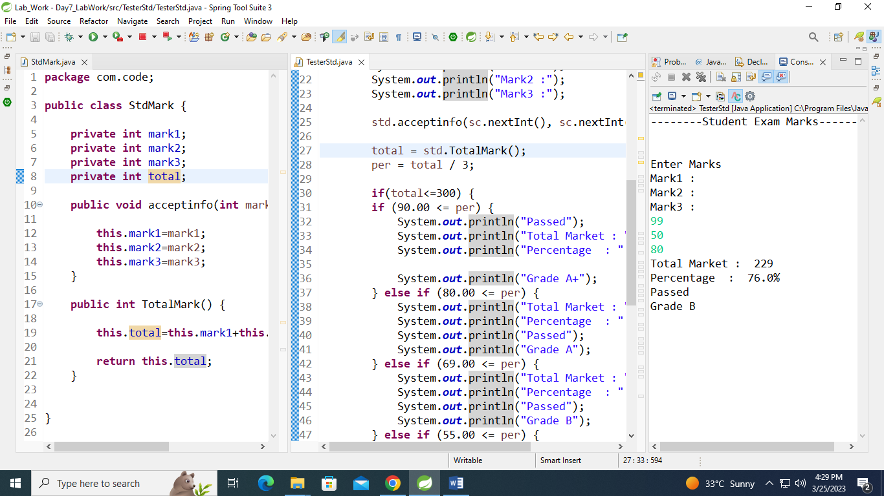

2. Create diff package and add class inside that.

Try to access one package class in another package....

(chk default access specifier)

Program :

**package** NewFolder;

**import** com.code.StdMark;

**import** TesterPackage.TesterPackage;

**public** **class** PackAcces {

// TesterPackage sc = new TesterPackage();

// TesterPackage Is default Class is not accesible outside the package

// StdMark sc1=new StdMark(); Public Class Accesible out side the Package

}

